

Grade 2 Unit 1

American Principles

|  |  |  |
| --- | --- | --- |
| **Previous Exposure** | **American Principles** | **Future Exposure** |
| In kindergarten and  grade 1, students explored the role of individuals in communities, traditions and symbols of the United States, how citizens help the community make decisions, and the choices Helen Keller, Jackie Robinson, Rosa Parks, and Cesar Chavez made that brought about community change. | Democratic ideals transcend time and place. The Grade 2 American Principles unit is designed to help students understand:   * how the culture of the United States reflects the diversity of its people * how American holidays commemorate American principles by recognizing the contributions of individuals and groups from the past * actions citizens can take to preserve and improve life in America in the present   In this unit, students will be introduced to the benefits of having a diverse community. They will discuss positive actions citizens can take to uphold American principles. Throughout the school year, these ideas will be reinforced through the study of famous Americans and American holidays (as they occur).  Hear a VBCPS teacher describe key components of this unit on [The Stream.](https://video.vbcps.com/viewerportal/vbcps/home.vp?programId=esc_program%3A19683) | In the Grade 3 American Society series, students will study the rights to life, liberty, the pursuit of happiness and equality under the law. Students will participate in a year-long study of individuals who embody democratic principles, as well as holidays that recognize the contributions of citizens who have worked to defend them. |

**American principles**

**Grade 2**

**Table of Contents**

Content Specifications ap-1

Enduring Understandings and Essential Questions ap-3

Unit Concept Map ap-4

Assessment Evidence ap-5

Materials and Resources Needed ap-6

Planning Guide ap-7

**Appendix**

*(All documents listed below are available on SharePoint.)*

**Week 1:**

**Unit Hook**

Famous American Matrix

Holiday Matrix

Famous Americans Preassessment

Friendship Venn Diagram

Diversity Quilt Square

**Introduction to Citizenship, Famous Americans, and Holidays**

Important People Mix-N-Match/Sort Cards

Citizenship Exit Ticket

Holidays Mix-N-Match/Sort Cards

**Throughout the School Year:**

**American Holidays**

Five Ponds: All-American Holidays

Days to Remember – Veterans Day

Reproducible 148: Martin Luther King, Jr.

Days to Remember – Martin Luther King, Jr. Day

Five Ponds: Hometown Heroes

Days to Remember - Memorial Day

American Holiday Assessment

**Famous Americans**

Five Ponds: Powhatan and Pocahontas

Five Ponds: Thurgood Marshall

Five Ponds: Eleanor Roosevelt

Who’s Who in American History?

Famous American Note Taking

Famous American Quiz

Test Bank

**American Principles** **Content Specifications**

**SS.2.0 The student will demonstrate knowledge and understanding of life in the United States and its location in the world.**

**Note to teacher:** *SS.2.0.1- SS.2.0.3 are introduced in the American Principles unit and can be reassessed throughout the year as appropriate. SS.2.04-SS.2.0.7 are introduced in the American Indians unit and can be reassessed during the Egypt and China units as appropriate. The SS.2.0 objectives are listed in every quarter. Teachers can use their professional judgment to determine when and how often they should be assessed, although suggestions are included in the Virginia Beach curriculum.*

SS.2.0.1 Explain how the culture of the United States reflects the diversity of its people. (SOL 2.12)

* Variety of ethnic and cultural groups in the community of Virginia Beach
* Variety of foods, music, and customs

SS.2.0.2 Describe how American holidays commemorate American principles by recognizing the contributions of individuals and groups from the past. (SOL 2.3, SOL 2.11, SOL 2.12,

SOL 3.11)

* Susan B. Anthony
* led the struggle to get equal rights for women and the right to vote
* Thurgood Marshall
* lawyer who defended people at a time when not all people had equal rights
* first African-American Justice of the United States Supreme Court
* Eleanor Roosevelt
* leader for equal rights for all people
* volunteered for many organizations
* Powhatan
* American Indian leader when the settlers came to Jamestown
* ruled over many tribes
* Pocahontas
* American Indian girl who came with her father’s people to visit the settlers at Jamestown
* worked to help the settlers receive food from the American Indians
* Martin Luther King, Jr.
* led peaceful marches and demonstrations to gain equal rights and treatment for African Americans
* Martin Luther King, Jr. Day
* recognition of the contributions of Rev. Martin Luther King, Jr.
* observed in January
* Veterans Day
* recognition and respect for Americans who served in the military
* observed in November
* Memorial Day
* recognition and respect for Americans who died in wars while serving their country
* observed in May

SS.2.0.3 Identify actions citizens can take to preserve and improve life in America in the present.

(SOL 2.10, SOL 2.12)

* Voting for officials to represent the needs and interests of the community
* Electing officials for Virginia local (city and county) and state governments
* Respecting the property rights of others
* Obeying the law
* Participating in community activities (e.g., Clean the Bay Day, Relay for Life, etc.)

**Enduring Understandings and Essential Questions**

*The standards included in this unit are intended to drive students toward broad ideas, or enduring understandings. Although these understandings are conceptual and lofty, all students will benefit from considering them, at least in part. Not all students will respond at the same level of depth or even manage each enduring understanding in its entirety; however, exposure is key. Over time, students will move toward deeper conceptual understandings. Essential questions are designed to help students reflect and discuss as they clarify their learning and begin to move toward managing the enduring understandings. At key points in the unit, the essential questions may be embedded. Based on student need, questions can be included through discussion and/or the process log.*

|  |  |
| --- | --- |
| **Enduring Understandings** | **Essential Questions** |
| * Democratic ideals transcend time and place. | * How are people united? * How do holidays and famous Americans represent American principles? * When should citizens take action? |

**Unit Concept Map**

*The concept map is designed to show the relationships among major concepts in a unit of study. This visual representation shows the connections between and among the concepts. This tool can be used to support instructional planning and student development of conceptual understandings.*

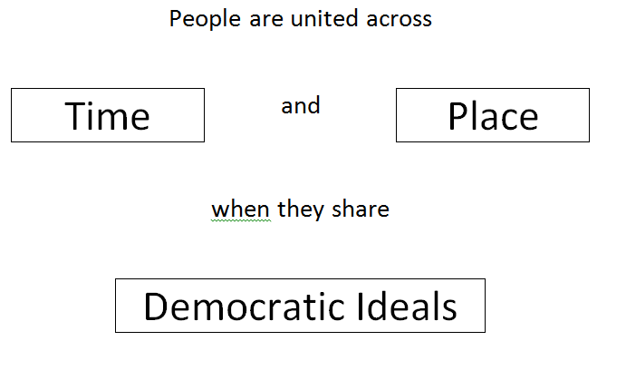

**Assessment Evidence**

|  |  |  |
| --- | --- | --- |
| **Preassessments** | **Performance Tasks** | **Other Evidence** |
| * Famous American Preassessment | * This unit does not contain a performance task and should be integrated with Language Arts as frequently as possible. | * Diversity Quilt Square (SS.2.0.1) * Citizenship Exit Ticket (SS.2.0.3) * Famous Americans Quiz (SS.2.0.2) * Days to Remember: (SS.2.0.2)    + Veterans Day   + Martin Luther King, Jr. Day   + Memorial Day * American Holiday Assessment (SS.2.0.2) |

|  |
| --- |
| **MATERIALS and RESOURCES Needed** |
| **Our World: Far and Wide - Five Ponds Press**  <http://www.fivepondspressbooks.com/>  Teacher access: Username: TVBeach (with capital letters TVB)  Password: T23456 (with a capital T)  Student and Parent Address: <http://www.fivepondspressbooks.com/studentbooks>  Username: VBeach (with capital letters VB)  Password: 23456  **Defined STEM**   * Family Culture |

**Planning Guide**

|  |  |
| --- | --- |
| **VBOs/ Assessments** | **Description of Instruction** |
| **Week 1**  SS.2.0.1  SS.2.0.3      **HPS: P** Diversity Quilt Square  **SS.2.0.1** Explain how the culture of the United States reflects the diversity of its people.    **HPS: AP** Citizenship Exit Ticket  **SS.2.0.3** Identify actions citizens can take to preserve and improve life in America in the present. | **Previous Exposure:**   * In kindergarten and grade 1, students explore the role of individuals in communities, traditions and symbols of the United States, how citizens help the community make decisions, and the choices Helen Keller, Jackie Robinson, Rosa Parks, and Cesar Chavez made that brought about community change.   **Note to teacher:** *The* *Famous American Matrix and* *Holiday Matrix shows how people and holidays are introduced across the K-3 social studies curriculum. The Five Ponds location indicates which textbook includes information about famous people and holidays. While some items are included in this document, teachers can also use the log in information in the* *Materials and Resources Needed* *section to access online textbooks for any grade level. Holidays and famous Americans not included in the second grade* Our World: Near and Far *textbook are included in this document for ease of use.*  **Preassessment:**   * Famous Americans Preassessment – Use data to determine student readiness for famous Americans studied in previous grade levels. *Students will list in a table what is important about famous Americans.*   **Note to teacher:** *Students indicating lack of readiness may need additional review throughout the year. Activities in this unit include previously studied Famous Americans.*    **Unit Hook:**   * Use classroom community-building activities to introduce students to the unit **Essential Question**, *How are people united*? Students should begin to recognize that while they are very different, they also have a lot in common. * Activities should focus specifically on what makes each student unique, but also on what they have in common, such as the attached Friendship Venn activity. * Use the games as an opportunity to discuss the unit **Essential Question**, *How are people united*?Students should begin to recognize that while they are very different, they also have a lot in common. Encourage this understanding using discussion prompts like those shown below:   + All students in this class…. (like playing outside)   + Most students in this class…. (play a sport)   + Some students in this class… (went on vacation this summer)   + I am the only student in this class who…. (takes karate) * Explain to students that the culture of the United States reflects the variety of foods, music, and customs of the people who live there. Teachers can use pages 16 and 17 of *Our World Near and Far* to introduce this idea. * Have the students discuss types of food they like to eat. Help students determine cultural groups associated with the types of food, noting that some foods are not associated with a specific cultural group and are considered uniquely American. * Repeat this process with music and customs or traditions. It may help to focus specifically on foods, music, and customs specific to the students in the class or the local community. * Have the students complete a Diversity Quilt Square. Students can write or draw and explain their answers.   **Note to teacher:** *This assessment will likely provide evidence of proficient understanding only. Advanced proficiency may be demonstrated through class discussions and a deepening understanding of present-day diversity through the study of ancient cultures in future units.*  Introduction to Citizenship. Famous Americans, and Holidays   * Have the students complete the Important People Mix-N-Match/Sort Card activity. Students should match the people with the correct definition. This activity includes all the famous Americans studied since kindergarten. Students should be familiar with Helen Keller, Jackie Robinson, Rosa Parks, and Cesar Chavez. The other cards can be used to assess prior knowledge of second grade famous Americans. * Explain to students that they will be studying famous Americans throughout the school year. As they learn about each individual, they will consider how each person demonstrated good citizenship. Discuss what makes someone a “good citizen”. Ask students: *how can good citizens help the community?* * Discuss with students the importance of voting, obeying the law, and participating in community activities using simple beginning of the year class activities such as creating class rules, establishing class jobs, etc. Use these opportunities to discuss the importance of being a good citizen in the classroom as well as the community. * If students are ready, administer the Citizenship Exit Ticket. Otherwise, this exit ticket can be used at another pivotal moment in the school year, such as just after winter break or at the end of the year.   **Note to teacher:** *A word bank is provided on this exit ticket. It can be removed to increase the complexity of the assessment.*   * Have the students complete the Holidays Mix-N-Match/Sort Card activity. Students were introduced to Columbus Day, Thanksgiving, Presidents’ Day, and Independence Day in first grade. Veterans Day, Martin Luther King, Jr. Day and Memorial Day should be introduced as they occur in second grade. |
| **Throughout the year**  SS.2.0.2    **HPS: AP** Days to Remember Exit Tickets  **SS.2.0.2** Describe how American holidays commemorate American principles by recognizing the contributions of individuals and groups from the past.  Veterans Day  Martin Luther King, Jr. Day  Memorial Day  **HPS: AP** American Holiday Assessment  (SS.2.0.2)    **HPS: AP** Famous Americans Quiz  (SS.2.0.2) | American Holidays  **Note to teacher:** *As American holidays occur throughout the year, teachers can use the opportunity to integrate social studies content with Language Arts. The activities and assessments below can be used, but teachers are also encouraged to take advantage of resources that can often be found around the time of year holidays occur.*   * Introduce students to Veterans Day around November 11. Explain to students that Veterans Day is celebrated to show recognition and respect for Americans who served in the military. * Students can read about the holiday, including stories of those who have served. Pages 88 and 89 of *Our World: Far and Wide* provide some basic background information. * Teachers are encouraged to connect with the local community and can encourage students to write thank you letters or draw pictures that honor our veterans. * Have the students complete the Days to Remember: Veterans Day exit ticket. * Introduce students to Martin Luther King, Jr. Day around January 19. Explain to students that Martin Luther King, Jr. Day is celebrated to recognize the contributions of Rev. Martin Luther King, Jr. * Students can read about the holiday using stories and picture books about the Civil Rights movement. Pages 90 and 91 of *Our World: Near and Far* provide some basic background information. Students can use the information to complete Reproducible 148. * Have the students complete the Days to Remember: Martin Luther King, Jr. Day exit ticket. * Introduce students to Memorial Day around May 25. Explain to students that Memorial Day is celebrated in recognition and respect for Americans who died in wars while serving their country. * Students can read about the holiday using stories and picture books about wars or military heroes. Pages 90 and 91 of *Our World: Far and Wide* provide some ideas for how students can be heroes, just like those who died in wars while serving their country. * Have the students complete the Days to Remember: Memorial Day exit ticket. * When students are ready, teachers may choose to administer the American Holiday Assessment for additional assessment evidence.   Famous Americans  **Note to teacher:** *The Famous Americans for second grade are grouped to occur at logical times throughout the school year. Powhatan and Pocahontas will likely be introduced during the American Indians unit. Thurgood Marshall and Martin Luther King, Jr. may be taught around Martin Luther King, Jr. Day or during Black History Month. Susan B. Anthony and Eleanor Roosevelt are likely to be introduced in March during Women’s History Month.* *Teachers can use these opportunities to integrate social studies content with Language Arts using the activities and assessments listed below or using resources that may be available in the building.*   * Introduce students to Powhatan and Pocahontas during the American Indians unit. It is important for students to understand that both individuals were from the Eastern Woodlands. Students will learn much more about the Powhatan in future school years. * Students can read books about the Eastern Woodland Indians in general, discussing what life might have been like at that place and time. Pages 60 and 61 of *Our World: Let’s Go* provide some basic background information about Powhatan and Pocahontas. * Introduce students to Martin Luther King, Jr. and Thurgood Marshall around Martin Luther King, Jr. Day or in February during Black History Month. Explain to students that both men fought for equal rights. Martin Luther King, Jr. led peaceful marches and demonstrations to gain equal rights and treatment for African Americans. Thurgood Marshall was a lawyer who defended people at a time when not all people had equal rights. He was the first African American Justice of the United States Supreme Court. * Students can read books about the Civil Rights movement to understand the context of the time period. This may be a good time to review Jackie Robinson, Cesar Chavez, and Rosa Parks, previously studied famous Americans who also worked for equal rights. Pages 78 and 79 of *Our World: Far and Wide* provide some basic background information about Thurgood Marshall specifically. * Introduce students to Susan B. Anthony and Eleanor Roosevelt in March during Women’s History Month. Explain to students that both women also worked for equal rights. Susan B. Anthony led the struggle to get equal rights for women and the right to vote. Eleanor Roosevelt was a leader for equal rights for all people. She volunteered for many organizations. * Students can read books about women’s suffrage and the early 20th century to understand the context of the time period. This may be a good time review Helen Keller, who was from around the same time period. Pages 84 and 85 of *Our World: Near and Far* provide some basic background information about Susan B. Anthony. Pages 44 and 45 of *Our World: Then and Now* provide some basic background information about Eleanor Roosevelt. * As students learn about each famous American, teachers may choose to have students complete graphic organizers such as the Who’s Who in American History? activity or compile a class list using a chart like the Famous American Note Taking sheet. This will help students distinguish between each famous American and review as needed. * When students are ready, teachers can administer the Famous Americans Quiz. Students should be able to articulate the relationship between famous Americans and American holidays in order to demonstrate advanced proficiency. * A test bank is provided on SharePoint with additional assessment items to assess the VBOs for the American Principles unit. |

**Famous American Matrix**

|  |  |  |  |
| --- | --- | --- | --- |
| **Grade Level** | **VBCPS Location** | **Five Ponds Location** | **Rationale** |
| K | Helen Keller | 2nd Grade | Kindergarten has a thematic focus of “self” and “choices.” Students will study Helen Keller and Jackie Robinson in terms of how the choices they made as individuals impacted the community. This study will include any other famous Americans who made individual choices that impacted the community. |
| Jackie Robinson | 2nd Grade |
| 1 | Cesar Chavez | 3rd Grade | First grade has a broader focus on “community” and “decisions.” Students will study how communities are impacted by the decisions people make throughout the past. They will revisit Helen Keller and Jackie Robinson through this lens, but will also add Cesar Chavez and Rosa Parks. |
| Rosa Parks | 3rd Grade |
| 2 | Powhatan | K | Second grade focuses on “world” as students begin their study of ancient civilizations. They will learn about Powhatan to distinguish between Powhatan the person and the Powhatan tribe when they learn about the Eastern Woodland Indians. They will also learn about individuals that had an impact beyond the community to the larger world. These “change agents” impacted civil rights, workers’ rights, and women’s rights. Students should also revisit Helen Keller, Jackie Robinson, Cesar Chavez, and Rosa Parks using the “change agent” lens. |
| Pocahontas | K |
| Martin Luther King, Jr. | 2nd Grade |
| Eleanor Roosevelt | 1st Grade |
| Susan B. Anthony | 2nd Grade |
| Thurgood Marshall | 3rd Grade |
| 3 | Betsy Ross | K | Third grade continues to focus on “world,” but also has specific content related to American symbols, explorers, and government. Betsy Ross will be taught with symbolism; Benjamin Franklin and George Washington Carver will be taught with science (as innovators); Christopher Columbus, Christopher Newport, Jacques Cartier, and Juan Ponce de Leon will be taught during the explorers unit; and Abraham Lincoln, George Washington and Thomas Jefferson will be taught during the government unit. All previous people should be reviewed when appropriate in third grade. |
| Benjamin Franklin | 1st Grade |
| George Washington Carver | 1st Grade |
| Christopher Columbus  Christopher Newport  Jacques Cartier  Juan Ponce de Leon | 3rd Grade |
| Abraham Lincoln | K-3rd Grade |
| George Washington | K-3rd Grade |
| Thomas Jefferson | 3rd Grade |

**Holiday Matrix**

|  |  |  |  |
| --- | --- | --- | --- |
| **Grade Level** | **VDOE Location** | **VBCPS Location** | **Rationale** |
| K | Thanksgiving Day  Martin Luther King, Jr. Day  Presidents’ Day  Independence Day | N/A | Holidays will be calendar focused in Kindergarten as students develop a sense of “self” (birthdays, family celebrations) and chronology. |
| 1 | Presidents’ Day  Columbus Day  Independence Day | Columbus Day  Thanksgiving  Presidents’ Day  Independence Day | Holidays have an “American” focus in first grade as students begin to understand what it means to be in a diverse community united by “American” principles and common celebrations. These American events should be taught as they occur chronologically. |
| 2 | N/A | Veterans Day  Martin Luther King, Jr. Day  Memorial Day | Holidays in second grade should focus on how events can honor past “change agents.” Veterans Day and Memorial Day are celebrations of everyday people, while Martin Luther King, Jr. Day celebrates a famous American who brought about change in our country and the world. |
| 3 | Veterans Day  Memorial Day | Columbus Day  Veterans Day  Thanksgiving  Martin Luther King, Jr. Day  Presidents’ Day  Memorial Day  Independence Day | Holidays in third grade should include all the holidays from previous years, as they occur chronologically, providing the opportunity to review concepts such as American symbolism and change agents. |
| Overall Rational | | | |
| It is important for students to learn American holidays with as much accuracy as possible to avoid misconceptions at later grade levels. The study of holidays provides great opportunity for integration, both in language arts (through stories and literature) and in mathematics (through calendar practice). | | | |

Famous Americans Preassessment

|  |  |
| --- | --- |
| **Famous American** | **What is important about this person?** |
| **Helen Keller** |  |
| **Jackie Robinson** |  |
| **Cesar Chavez** |  |
| **Rosa Parks** |  |

Famous American Preassessment (Sample Responses)

|  |  |
| --- | --- |
| **Famous American** | **What is important about this person?** |
| **Helen Keller** | *She overcame her disabilities and worked to help others who were blind and deaf.* |
| **Jackie Robinson** | *He was the first African American player in the major leagues of baseball. His actions helped to bring about opportunities for other African Americans.* |
| **Cesar Chavez** | *He was a Mexican American who worked to improve conditions for farm workers.* |
| **Rosa Parks** | *She was an African American woman who refused to give up her seat on a public bus as was required by law many years ago. She helped bring about changes in laws and worked so that all people would have equal rights.* |

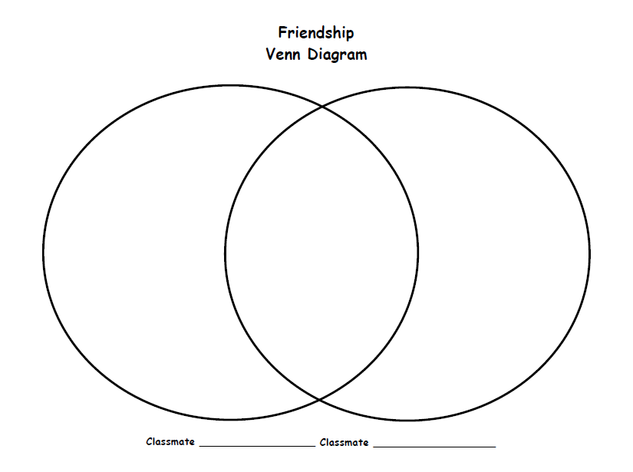  
[https://www.cape.k12.mo.us/blanchard/hicks/**FriendshipVenn**.pdf](https://www.cape.k12.mo.us/blanchard/hicks/FriendshipVenn.pdf)

Diversity Quilt Square

**Directions**: *How are people in Virginia Beach different? Brainstorm food, customs, and music that represent ethnic and cultural groups in Virginia Beach.*

|  |  |
| --- | --- |
| Food  C:\Users\mfrafter\AppData\Local\Microsoft\Windows\Temporary Internet Files\Content.IE5\QHP46CKE\MC900434969[1].wmf | Customs  C:\Users\mfrafter\AppData\Local\Microsoft\Windows\Temporary Internet Files\Content.IE5\PQA70CDP\MC910229341[1].wmf |
| Music  C:\Users\mfrafter\AppData\Local\Microsoft\Windows\Temporary Internet Files\Content.IE5\J2VZDRYL\MC900441798[1].png | Other |

**HPS: P**SS.2.0.1 Explain how the culture of the United States reflects the diversity of its people.

Diversity Quilt Square Sample Responses

Students may draw and explain or write. Images from: [*http://www.teaching.com.au/home*](http://www.teaching.com.au/home)

|  |  |
| --- | --- |
| *Responses should show several examples of diversity in Virginia Beach.* | |
| Food  *C:\Users\mfrafter\AppData\Local\Microsoft\Windows\Temporary Internet Files\Content.IE5\QHP46CKE\MC900434969[1].wmf*  *For example: tacos and tortillas (Mexico), pizza (Italy), sushi (Japanese), lumpia Filipino), peanuts (enslaved Africans), chocolate (South America)* | Customs  C:\Users\mfrafter\AppData\Local\Microsoft\Windows\Temporary Internet Files\Content.IE5\PQA70CDP\MC910229341[1].wmf  *For example: dances, wedding traditions, holidays, family relationships* |
| Music  C:\Users\mfrafter\AppData\Local\Microsoft\Windows\Temporary Internet Files\Content.IE5\J2VZDRYL\MC900441798[1].png  *For example: jazz, blues, gospel, rock, rap, hip hop, salsa* | Other  *For example: clothing, peoples’ names, style of homes* |

**HPS: P**SS.2.0.1 Explain how the culture of the United States reflects the diversity of its people.

Important People Mix-N-Match/Sort Cards

|  |  |
| --- | --- |
| Overcame her disabilities and worked to help others who were blind and deaf | The first African American player in the major leagues of baseball; his actions helped bring about other opportunities for African Americans |
| Led the peaceful marches and demonstrates to gain equal rights and treatment for African Americans | American Indian leader when the settlers came to Jamestown; ruled over many tribes |
| American Indian girl, daughter of Powhatan, who came with her father’s people to visit the settlers at Jamestown; worked to help the settlers receive food from the American Indians | Lawyer who defended people at a time when not all people had equal rights; first African American Justice of the United States Supreme Court |
| Led the struggle to get equal rights for women and the right to vote | African American woman who refused to give up her seat on a public bus, as was required by law many years ago (1950s) |
| Mexican American man who worked to improve conditions for farm workers | Leader for equal rights for all people; volunteered for many organizations |

**Important People Mix-N-Match/Sort Cards**

|  |  |
| --- | --- |
| Helen Keller | Jackie Robinson |
| Martin Luther King, Jr. | Powhatan |
| Pocahontas | Thurgood Marshall |
| Susan B. Anthony | Rosa Parks |
| Cesar Chavez | Eleanor Roosevelt |

Citizenship Exit Ticket

C:\Users\mfrafter\AppData\Local\Microsoft\Windows\Temporary Internet Files\Content.IE5\J0C96GST\MC900078780[1].wmf

*Directions:* *Draw and label a picture that shows how the actions can improve life in America.*

|  |  |  |  |
| --- | --- | --- | --- |
| voting in elections | respecting others’ property | obeying the law | participating in community activities |

|  |
| --- |
|  |
|  |
|  |

**HPS: AP**

SS.2.0.3Identify actions citizens can take to preserve and improve life in America in the present.

Citizenship Exit Ticket Sample Response

C:\Users\mfrafter\AppData\Local\Microsoft\Windows\Temporary Internet Files\Content.IE5\J0C96GST\MC900078780[1].wmf

*Directions:* *Draw and label a picture that shows how the actions can improve life in America.*

|  |  |  |  |
| --- | --- | --- | --- |
| voting in elections | respecting others’ property | obeying the law | participating in community activities |

|  |
| --- |
| C:\Users\mfrafter\AppData\Local\Microsoft\Windows\Temporary Internet Files\Content.IE5\CTQR0FXP\MC900301360[1].wmf |
| Citizens can vote for someone to make choices that meet the needs and wants of the |
| community |

**HPS: AP**

SS.2.0.3Identify actions citizens can take to preserve and improve life in America in the present.

Holidays Mix-N-Match/Sort Cards

|  |  |
| --- | --- |
| Recognition of Christopher Columbus, who is given credit for discovering America; observed in October | Recognition and respect for Americans who served in the military; observed in November |
| Recognition of the sharing of the harvest with the American Indians; observed in November | Recognition of the contributions of Rev. Martin Luther King, Jr. who led peaceful marches and demonstrations to gain equal rights and treatment for African americans; observed in January |
| Recognition of all United States presidents, especially George Washington and Abraham Lincoln; observed in February | Recognition and respect for Americans who died in wars while serving their country; observed in May |
| Recognition of when America became a new country; sometimes called America’s birthday; observed in July |  |

|  |  |
| --- | --- |
| Independence Day (Fourth of July) | Memorial Day |
| Presidents’ Day | Martin Luther King, Jr. Day |
| Thanksgiving Day | Veterans Day |
| Columbus Day |  |

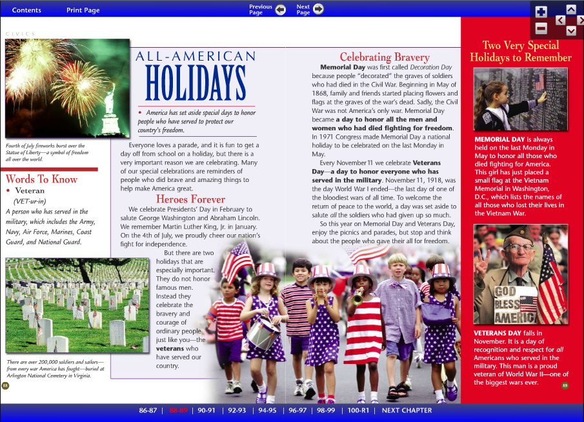

Days to Remember – Veterans Day

Draw a picture that represents this holiday.

When is this holiday observed? ___________________________________________________

What do Americans recognize on this day?

|  |
| --- |
|  |

How does this holiday commemorate American principles?

|  |
| --- |
|  |
|  |

**HPS: AP**

SS.2.0.2 Describe how American holidays commemorate American principles by recognizing the contributions of individuals and groups from the past.

Days to Remember – Veterans Day (Sample Response)

**Draw a picture that represents this holiday.**

*Pictures will vary. They might include patriotic symbols and/or military figures.*

**When is this holiday observed?**  *November*

**What do Americans recognize on this day?**   
  
*recognition and respect for Americans who served in the military*

**How does this holiday commemorate American principles?***Answers might include: many people know or are related to someone who has served in the military, we all enjoy the freedoms and privileges that the military works to protect, develops a sense of national pride and heritage*

**HPS: AP**

SS.2.0.2 Describe how American holidays commemorate American principles by recognizing the contributions of individuals and groups from the past.

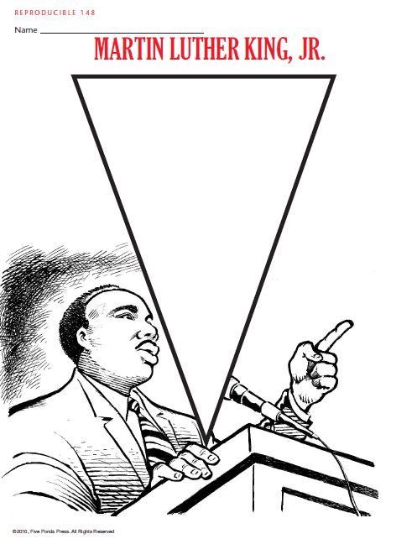

Days to Remember – Martin Luther King, Jr. Day

Draw a picture that represents this holiday.

When is this holiday observed? ___________________________________________________

What do Americans recognize on this day?

|  |
| --- |
|  |

How does this holiday commemorate American principles?

|  |
| --- |
|  |
|  |

**HPS: AP**

SS.2.0.2 Describe how American holidays commemorate American principles by recognizing the contributions of individuals and groups from the past.

Days to Remember – Martin Luther King, Jr. Day (Sample Response)

**Draw a picture that represents this holiday.**

*Pictures will vary. They might include a portrait of Dr. King or images of diverse people coming together in peaceful activities.*

**When is this holiday observed?**

*January*

**What do Americans recognize on this day?**

*recognition of the contributions of Rev. Martin Luther King, Jr., who led peaceful marches and demonstrations to gain equal rights and treatment for African Americans*

**How does this holiday commemorate American principles?***Answers might include: all people are created equal, Dr. King let everyone know that their voice could be heard when they work together, everyone deserves to be treated fairly in the United States*

**HPS: AP**

SS.2.0.2 Describe how American holidays commemorate American principles by recognizing the contributions of individuals and groups from the past.

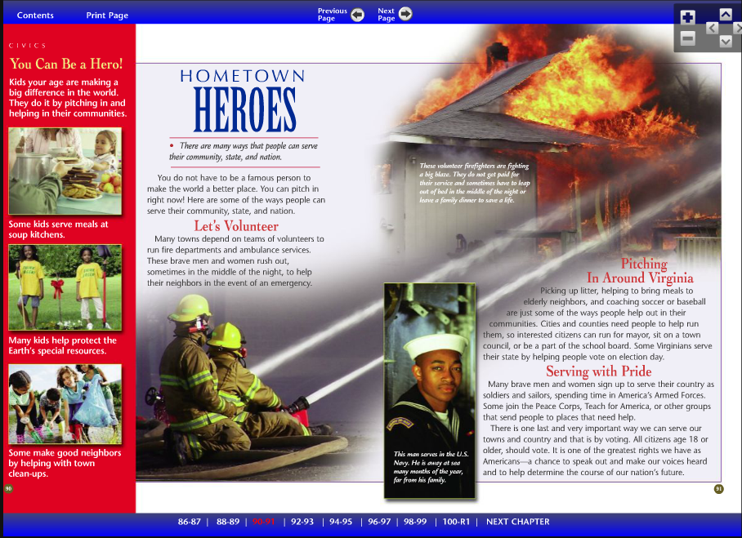

Days to Remember – Memorial Day

Draw a picture that represents this holiday.

When is this holiday observed? ___________________________________________________

What do Americans recognize on this day?

|  |
| --- |
|  |

How does this holiday unite the diverse people of the United States?

|  |
| --- |
|  |
|  |

**HPS: AP**

SS.2.0.2 Describe how American holidays commemorate American principles by recognizing the contributions of individuals and groups from the past.

Days to Remember - Memorial Day (Sample Response)

**Draw a picture that represents this holiday.**

*Pictures will vary. They may include various patriotic symbols, such as the flag, or images of gravesites or memorials that have been created throughout the country.*

**When is this holiday observed?**

*May*

**What do Americans recognize on this day?**

*recognition and respect for Americans who died in wars while serving their country*

**How does this holiday commemorate American principles?**

*Answers might include: celebrate the contributions of people who have died serving our country, we all enjoy the freedoms and privileges that these people died to protect, develops a sense of national pride and heritage*

**HPS: AP**

SS.2.0.2 Describe how American holidays commemorate American principles by recognizing the contributions of individuals and groups from the past.

Name _________________________________

**American Holiday Assessment**

**Directions:** In each box explain the two American holidays created to honor people who have served to protect the country’s freedom.

1. Whom do we honor on Veterans Day?

When is it celebrated?

2. Whom do we honor on Memorial Day?

When is it celebrated?

**Directions:** Select the best answer.

3. Who is the person we honor in January that led peaceful marches and demonstrations to gain equal rights and treatment for African Americans?

A. Susan B. Anthony

B. Eleanor Roosevelt

C. Thurgood Marshall

D. Martin Luther King, Jr.

**Directions:** Answer the following question using complete sentences.

4. Choose one of the holidays that Americans celebrate. Explain how celebrating this holiday commemorates American principles.

____________________________________________________________________________________________________________________________________________________________________________________________________________________________________________________________________________________________________________________________________________________________________________________________________________

**HPS: AP**

SS.2.0.2 Describe how American holidays commemorate American principles by recognizing the contributions of individuals and groups from the past.

Name _________________________________

**American Holiday Assessment – Sample Response**

1. **Whom do we honor on Veterans Day?**

*military members who have served our country*

**When is it celebrated?**

*November*

**2. Whom do we honor on Memorial Day?**

*People who have died in wars while serving our country*

**When is it celebrated?**

*May*

3.*D.*

4. *Answers will vary. Student responses should reflect an understanding of how that particular holiday commemorates American principles.*

**HPS: AP**

SS.2.0.2 Describe how American holidays commemorate American principles by recognizing the contributions of individuals and groups from the past.

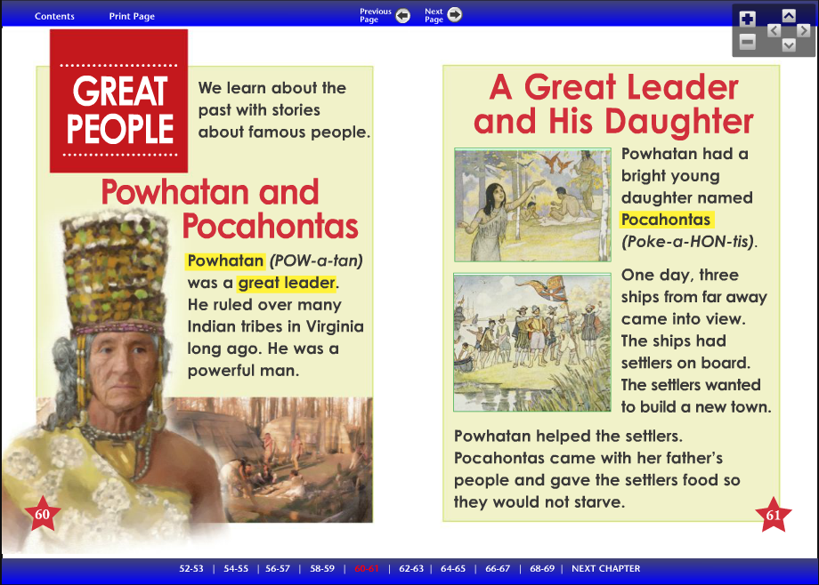

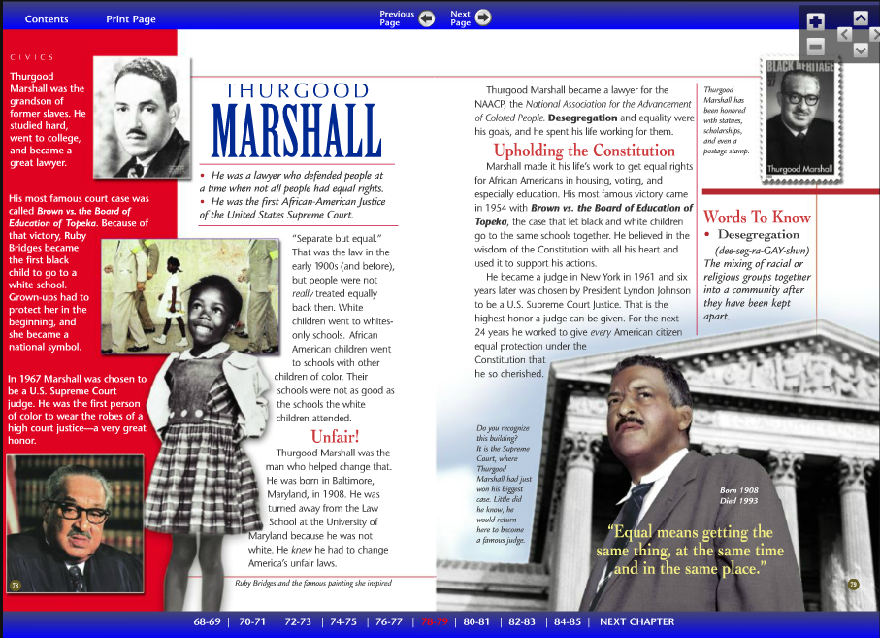

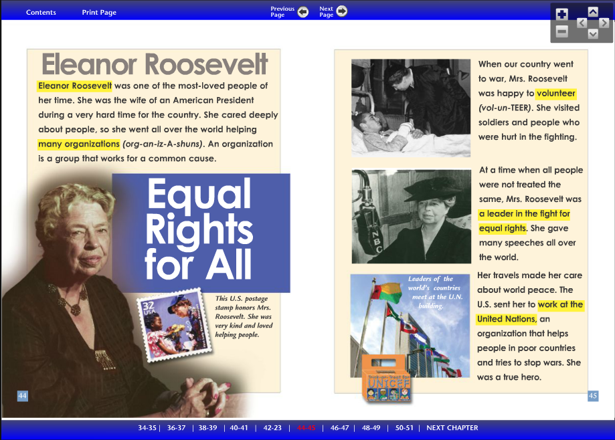

Who’s Who in American History?

# Illustration

Person____________________________

Place of Birth______________________

Birth Death ___________

Important Facts

|  |
| --- |
|  |
|  |
|  |
|  |

Write about this person’s contribution.

Famous American Note Taking

|  |  |  |
| --- | --- | --- |
| Famous American | What’s important about this person? | How will I remember this person?  (Illustration) |
|  |  |  |
|  |  |  |
|  |  |  |
|  |  |  |
|  |  |  |

Name_________________________

**Famous Americans Quiz**

**Directions**: Choose a person from the word bank that best matches each statement.

**Word bank:** Susan B. Anthony Thurgood Marshall Powhatan

Eleanor Roosevelt Martin Luther King, Jr.

1. ______________________________ This person was an American Indian leader who ruled over many tribes when the settlers came to Jamestown.

1. ______________________________ This person was a lawyer who defended people at a time when not all people had equal rights. This person was also the first African- American Justice of the United States Supreme Court.
2. ______________________________ This person led the struggle to get equal rights for women and the right to vote.
3. ______________________________ This person led the peaceful marches and demonstrations to gain equal rights and treatment for African Americans.
4. ______________________________ This person was a leader for equal rights for all people and volunteered for many organizations.
5. How do American holidays such as Black History Month and Women’s History Month honor American principles?

|  |
| --- |
|  |
|  |
|  |

**HPS: P**

SS.2.0.2 Describe how American holidays commemorate American principles by recognizing the contributions of individuals and groups from the past.

**Famous Americans Quiz Sample Response**

1. *Powhatan*

1. *Thurgood Marshall*
2. *Susan B. Anthony*
3. *Martin Luther King, Jr.*
4. *Eleanor Roosevelt*
5. *Black History Month helps us remember the contributions of people from the past such as Thurgood Marshall and Martin Luther King, Jr. Women’s History Month helps us to remember women from the past such as Susan B. Anthony and Eleanor Roosevelt. All of these people worked to make sure people were treated equally. Some helped make sure everyone could vote or volunteered to help others.*

**HPS: P**

SS.2.0.2 Describe how American holidays commemorate American principles by recognizing the contributions of individuals and groups from the past.

Test Bank

Teachers can use the test bank to create their own tests, offer questions as formative practice, or as exit tickets. Teachers can also use provided questions as a model for creating their own questions. In cases where teachers feel a question needs to be modified, they are welcome to do so.

The test bank questions demonstrate how content may be assessed on the SOL test. Additional assessments in the curriculum documents provide an alternative assessment opportunity specifically aligned to the VBOs. In a balanced-assessment environment, both types of assessment should be used.

The test bank can be downloaded from SharePoint.

Available Questions for American Principles

|  |  |
| --- | --- |
| **SS.2.0 The student demonstrates knowledge and understanding of life in the United States and its location in the world.** | |
| SS.2.0.1 | Explain how the culture of the United States reflects the diversity of its people. (SOL 2.12) |
| SS.2.0.2 | Describe how American holidays commemorate American principles by recognizing the contributions of individuals and groups from the past.  (SOL 2.3, SOL 2.11, SOL 2.12, SOL 3.11) |
| SS.2.0.3 | Identify actions citizens can take to preserve and improve life in America in the present. (SOL 2.10, SOL 2.12) |