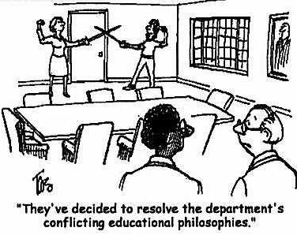**Let’s Write our**

**Philosophy of**

**Teaching…**

One of the things you will be required to write at one time or another in your teaching career will be your philosophy of teaching. What is a philosophy of teaching? It’s a short composition about what you believe the teaching profession is all about. It describes you and your methods, ideas, and beliefs about this noble career.

One of your jobs this quarter is to write your own personal philosophy of teaching. It’s not too long, not too short, not too stuffy, not too informal, and definitely not too boring. It’s all about YOU. It should have personality and panache…style and substance…facts and fabulousness. When people read your philosophy, they should hear you speaking, elaborating, talking about your passion for the field of education.

How do you get started? First, let’s look at some examples of teaching philosophies. Then, to brainstorm some ideas for your composition, consider your answers to the following questions…

* *Who are you as a teacher?*

**DEADLINE SCHEDULE…**

**rough draft due... 03/07/16**

**peer editing due… 03/07/16**

**final copy due… 03/21/16**

* *Who are you as a person?*
* *When you design lessons, what comes first?*
* *Why is working with kids important?*
* *Were you ever greatly inspired by a teacher?*
* *What does a typical lesson look like?*
* *How do you manage your classroom?*
* *C:\Users\jmmerrit\AppData\Local\Microsoft\Windows\Temporary Internet Files\Content.IE5\VNA904N7\MC900187587[1].wmfWhat is a teacher’s purpose?*
* *How do you feel when you teach?*

**Be careful to…**

* **not use second person (you, your)**
* **not to say *I believe, I feel, I think* (just say it)**
* **read your sentences out loud to hear your words; sometimes it makes sense in your head, but not to the reader**
* *What do good teachers do?*
* *Do lesson ideas pop into your head all the time?*
* *What was your initial motivation to enter the teaching profession?*
* *How do you reach all students?*
* *What does your favorite teacher do that you would like to emulate?*
* *What are some stories that demonstrate your teaching philosophy?*
* *When did you know you wanted to become a teacher?*
* *What are some quotes from your students that embody what teaching is all about?*
* *What is a teacher’s role in society?*
* *Twenty years from now, what do you want your teaching reputation to be? What would you want your students to say about you?*

**Now, don’t forget about the components of a good essay! You definitely want to add things like…**

***\*a motivator/hook *anecdotes/stories *rhetorical strategies *excellent details *strong ending***

**HAPPY WRITING!**